Little Lambs Mother’s Day Out Program
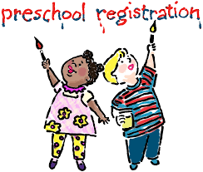
A Ministry of Liberty Baptist Church

2022-2023
Program Registration
is here!!!

Beginning, January 4th, early enrollment will begin for families
with children currently enrolled at Little Lambs MDO, their siblings,
and members of Liberty Baptist Church. Early enrollment will
continue throughout the month of January. On Monday, February 7th, enrollment will be available for children from the community at
large on a first come basis. Limited space is available!!
Register early to secure your child’s position!!

Placement for children in Little Lambs MDO classes will be
determined by their age on September 2nd of the current school year.
The September 2nd date is the same date used in the Shelby County
School System and has been chosen for educational purposes.
For example: Your child must be three (3) years old on or before
September 2nd in order to enter the three-year-old program.

A completed registration form must be turned in along
with the Registration Fee BEFORE your child can be enrolled.
Your child’s current year’s account MUST be up-to-date to enroll for the following year. The director or such person or persons designated by the director, shall review, approve or deny all applications for enrollment.
Once your registration form and fee have been received, you will be notified if your registration process is complete and your child will have a position in our Fall classes.

Children with possible or identified special needs shall be reviewed
and admittance shall be based on our ability to meet the child’s needs.

Registration Fees
Student currently enrolled in MDO: $ 40.00
New Students (includes siblings that are not currently enrolled): $ 50.00
Please note that registration fees are non-refundable and non-transferable.

